“The Ravine”
Study Guide
Critical vocabulary (32 % of test grade)
Gnarly (Adj.) – Describes something that has many knots or bumps on the surface. An uneven surface.
Rivulet (Noun) – A small river or stream.
Cascade (Verb) – To fall, pour, or rush in stages.
Precipice (Noun) – An overhanging or extremely steep area of rock
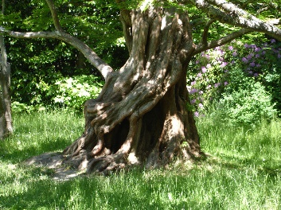
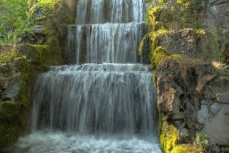
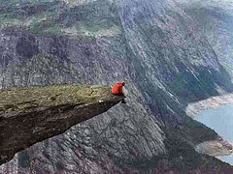
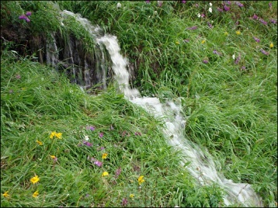
Comprehension – Key questions
- What details tell why the setting of the story is important?
- How does Vinny feel about his experiences in the story?
- Why is the stone goddess important?
- Why does Vinny get annoyed by Joe-Boy?
- Why does Vinny climb to the highest ledge?
- How does Vinny develop from the beginning to the end of the story?
- What effect do Vinny’s parents have on him in the story?
- How does Vinny feel by the end of the story?
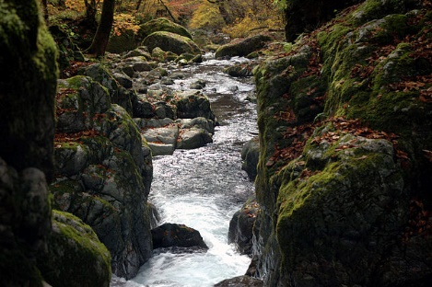
- Why does he finally begin to notice the beauty of the setting?

