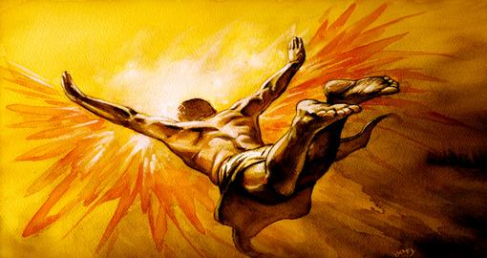
The Flight of Icarus
Comprehension Check Questions
- Analyze Story Elements: Myth (RL1.1; RL1.3): Re-read lines 10-12. What have we learned about Daedalus so far? What context clues hint that he may have unusual or supernatural powers?
- Determine Theme (RL1.1; RL1.3): Re-read lines 4-12. Identify what Daedalus and Icarus want.
- Determine Theme (RL1.1; RL1.2): Re-read lines 15-29. Summarize what Daedalus does to help himself and his son escape the island. Re-read lines 39-47. Cite evidence that suggests his plan will not go well.
- Analyze Story Elements: Myth (RL1.1; RL1.2; RL1.3): Re-read lines 57-63. Cite textual evidence that demonstrates the two key aspects of a myth. Re-read lines 60-79. Identify the cause of Icarus’ fall and explain what his failure tells us about the cultural values of the ancient Greeks.
- Determine Theme (RL1.1; RL1.2): Identify Daedalus’ original goal from the start of the myth. Re-read lines 88-95. Identify whether he succeeded or failed, and what this might reveal about the theme of the story. What lesson can the reader learn?
Icarus’s Flight
- Analyze Form: Poetry (RL1.1; RL 2.5): Re-read lines 1-8. Identify the number of lines in each stanza, whether the lines rhyme, and the types of end punctuation used. What is the effect of these elements on the meaning of the poem?
- Determine Meaning of Words and Phrases: Alliteration (RL1.1; RL 2.4): Re-read lines 10-16. Identify the alliterative words and explain how these words affect the poem.

