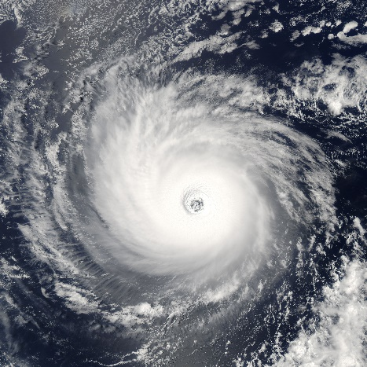
“After the Hurricane/Watcher”
Unit 3 Comprehension test Study Guide
Multiple-Choice Responses (80 marks)
- Who is the speaker (narrator) in “After the Hurricane?”
- What is the main narrative in “After the Hurricane?”
- Why does Freddie leave her family in the convention center?
- What does the line “citizen’s herded” describe?
- How does Freddie show her feelings when she sees the sign outside Doolie’s?
- What is the overall tone of “After the Hurricane?”
- Why is the subject (main character) watching in “Watcher?”
- What does the phrase “no-one said remains” emphasize or show?
- What do both poems tell about?
- What important idea is shared by both poems?
Written response (20 marks)
Use text details to support your response:
- What does the phrase “the world is here but no-one is watching” in “After the Hurricane” mean?
- Who are the watchers in each poem and what do they do?
Hint: there is only one watcher in “Watcher” but there are many different watchers in “After the Hurricane.”

