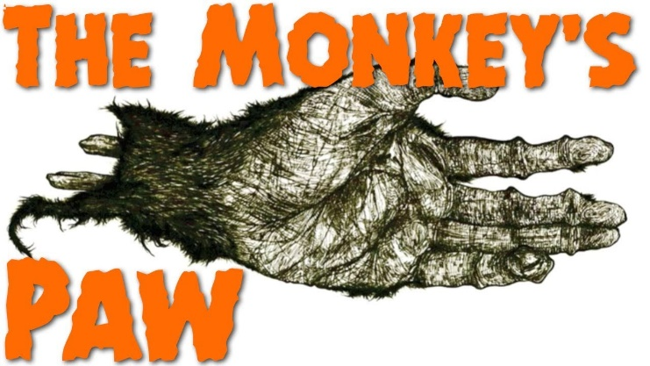
“The Monkey’s Paw”
Unit 3 Test: Study Guide
Critical Vocabulary (40 marks)
- Peril – Something that is dangerous
- Grimace – A facial expression showing pain or disgust
- Fate – A power that determines a course of events
- Credulity – A tendency to believe to easily
- Compensation – Payment received for loss or damage
Multiple-Choice Comprehension (40 marks)
- What action shows Sargent-Major Morris thought the paw was dangerous?
- What detail foreshadows the Monkey’s paw may be magical when Mr. White holds it?
- Why does Mr. Morris wish for 200 pounds?
- Why does Mr. White refuse to open the door for his wife?
- What is the theme of the story?
Written response (20 marks)
Responses must be supported with text evidence:
- Why does Herbert suggest what Mr. White should wish for?
- How does the mood, or feeling, contrast before and after Morris’ visit to the Whites?

