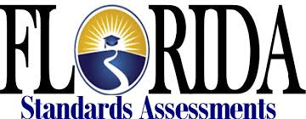

Eighth Grade Session 1
Key Ideas and Details

- I can make and support inferences using evidence from the text.
- I can determine multiple central ideas in a text.
- I can analyze the relationships between individuals, ideas, and events.

Text 2
Baby Hitler Hoax
Article
Excerpt from The History of Hoaxes
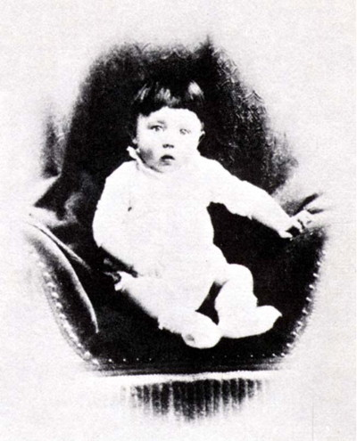
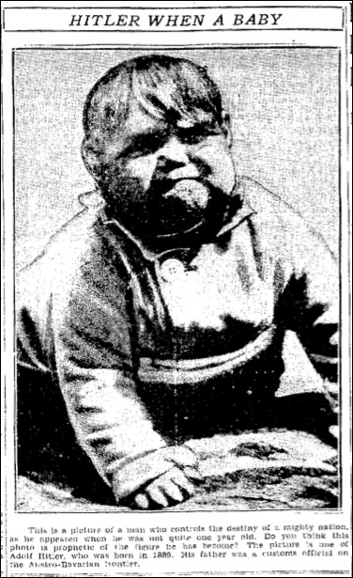
In 1933, a picture supposedly showing Adolf Hitler as a baby began circulating throughout England and America. The child in the picture looked positively menacing. Its fat mouth was twisted into a sneer, and it scowled at the camera from dark, squinted eyes. A greasy mop of hair fell over its forehead.
The image was distributed by Acme Newspictures, Inc. and appeared in many newspapers and magazines. For instance, in October 1933 the Chicago Tribune printed it alongside a photo of the adult Hitler addressing 500,000 farmers and storm troopers, above the caption, "Two Pictures of Hitler." The Winnipeg Free Press ran the picture with the caption: "This is a picture of a man who controls the destiny of a mighty nation, as he appeared when he was not quite one year old. Do you think this photo is prophetic of the figure he has become? The picture is one of Adolf Hitler, who was born in 1889."
However, the baby picture didn't actually show the infant führer.
Subsequent investigation by Acme Newspictures found that the Baby Adolf picture had come from the syndicate's London bureau, which, in turn, received it from Austria, Hitler's native country. Beyond that, the trail went cold. The identity of the hoaxer was unknown.
The Baby Identified
Actual photo of Adolf Hitler as a baby.
If the baby in the picture wasn't Adolf Hitler, then who was it? The answer to this question wasn't known until 1938.
Mrs. Harriet Downs of Ohio happened to see the picture in a magazine and immediately recognized it as her son (by a former marriage), John May Warren. However, in the original image her son looked cute, bright, and wholesome. Someone had darkened the shadows around the child's face to give him a more sinister look.
Mrs. Downs contacted Acme Newspictures, who, in May 1938, issued a correction:
"The picture purporting to be that of Baby Hitler actually was a photograph of 2-year-old John May Warren, then of Westport, Conn., now residing in Lakewood, Ohio... Recently, Mrs. Harriet M.W. Downs noticed the false picture reprinted in a magazine and recognized it as a photo of her son by a former marriage, John May Warren, now grown into a strapping, freckled schoolboy of eight years, who looks nothing like Hitler. The original snapshot had been retouched so that a baby cap was painted out and the features distorted so that what had been a babyish squint in the true picture appeared as a particularly unpleasant grimace."
It still remained a mystery how John Warren's picture had ended up in Austria in the hands of a photo forger. That mystery has never been solved.
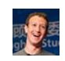
Text 3

Mark Zuckerberg
Social Media
Post
November 12 at 10:15pm ·

Our goal is to give every person a voice. We believe deeply in people. Assuming that people understand what is important in their lives and that they can express those views has driven not only our community, but democracy overall. Sometimes when people use their voice though, they say things that seem wrong and they support people you disagree with.
After the election, many people are asking whether fake news contributed to the result, and what our responsibility is to prevent fake news from spreading. These are very important questions and I care deeply about getting them right. I want to do my best to explain what we know here.
Of all the content on Facebook, more than 99% of what people see is authentic. Only a very small amount is fake news and hoaxes. The hoaxes that do exist are not limited to one partisan view, or even to politics. Overall, this makes it extremely unlikely hoaxes changed the outcome of this election in one direction or the other.
That said, we don't want any hoaxes on Facebook. Our goal is to show people the content they will find most meaningful, and people want accurate news. We have already launched work enabling our community to flag hoaxes and fake news, and there is more we can do here. We have made progress, and we will continue to work on this to improve further.
This is an area where I believe we must proceed very carefully though. Identifying the "truth" is complicated. While some hoaxes can be completely debunked, a greater amount of content, including from mainstream sources, often gets the basic idea right but some details wrong or omitted. An even greater volume of stories express an opinion that many will disagree with and flag as incorrect even when factual. I am confident we can find ways for our community to tell us what content is most meaningful, but I believe we must be extremely cautious about becoming the deciders of truth ourselves.
As we continue our research, we are committed to always updating you on how News Feed evolves. We hope to have more to share soon, although this work often takes longer than we'd like in order to confirm changes we make won't introduce unintended side effects or bias into the system.

Text 4

The First Amendment
Seminal US Document

Congress shall make no law respecting an establishment of religion, or prohibiting the free exercise thereof; or abridging the freedom of speech, or of the press, or the right of the people peaceably to assemble, and to petition the Government for a redress of grievances.

Fake Or Real? How To Self-Check
Article
Text 5

The News And Get The Facts
WYNNE DAVIS December 5, 201612:55 PM
1Fake news stories can have real-life consequences. On Sunday, police said a man with a rifle who claimed to be "self-investigating" a baseless online conspiracy theory entered a Washington, D.C., pizzeria and fired the weapon inside the restaurant.
So, yes, fake news is a big problem.
2These stories have gotten a lot of attention, with headlines claiming Pope Francis endorsed Donald Trump in November's election and sites like American News sharing misleading stories or taking quotes out of context. And when sites like DC Gazette share stories about people who allegedly investigated the Clinton family being found dead, the stories go viral and some people believe them. Again, these stories are not true in any way.

3Stopping the proliferation of fake news isn't just the responsibility of the platforms used to spread it. Those who consume news also need to find ways of determining if what they're reading is true. The idea is that people should have a fundamental sense of media literacy. And based on a study recently released by Stanford University researchers, many people don't.

4Sam Wineburg, a professor of education and history at Stanford and the lead author of the study, said a solution is for all readers to read like fact checkers. But how do fact checkers do their job?

5Alexios Mantzarlis, director of the International Fact-Checking Network at Poynter, says fact checkers have a process for each claim they deal with. There’s a framework for professionals, but there are ways for everyone to do a bit of fact checking themselves. We offer several tips below.

6Melissa Zimdars is an assistant professor of communication and media at Merrimack College in North Andover, Mass. When she saw her students referencing questionable sources, she created and shared a document with them of how to think about sources, as well as a list of misleading, satirical and fake sites. Both Mantzarlis and Zimdars agreed there are a few best practices people can use when reading articles online.

Pay attention to the domain and URL
7Established news organizations usually own their domains and they have a standard look that you are probably familiar with. Sites with such endings like .com.co should make you raise your eyebrows and tip you off that you need to dig around more to see if they can be trusted. This is true even when the site looks professional and has semi-recognizable logos. For example, abcnews.com is a legitimate news source, but abcnews.com.co is not, despite its similar appearance.

Read the "About Us" section
8Most sites will have a lot of information about the news outlet, the company that runs it, members of leadership, and the mission and ethics statement behind an organization. The language used here is straightforward. If it's melodramatic and seems overblown, you should be skeptical. Also, you should be able to find out more information about the organization's leaders in places other than that site.
Look at the quotes in a story
9Or rather, look at the lack of quotes. Most publications have multiple sources in each story who are professionals and have expertise in the fields they talk about. If it's a serious or controversial issue, there are more likely to be quotes — and lots of them. Look for professors or other academics who can speak to the research they've done. And if they are talking about research, look up those studies.
Look at who said them
10Then, see who said the quotes, and what they said. Are they a reputable source with a title that you can verify through a quick Google search? Say you're looking at a story and it says President Obama said he wanted to take everyone's guns away. And then there's a quote. Obama is an official who has almost everything he says recorded and archived. There are transcripts for pretty much any address or speech he has given. Google those quotes. See what the speech was about, who he was addressing and when it happened. Even if he did an exclusive interview with a publication, that same quote will be referenced in other stories, saying he said it while talking to the original publication.
Check the comments
11A lot of these fake and misleading stories are shared on social media platforms. Headlines are meant to get the reader's attention, but they're also supposed to accurately reflect what the story is about. Lately, that hasn't been the case. Headlines often will be written in exaggerated language with the intention of being misleading and then attached to stories that are about a completely different topic or just not true. These stories usually generate a lot of comments on Facebook or Twitter. If a lot of these comments call out the article for being fake or misleading, it probably is.
Reverse image search
12A picture should be accurate in illustrating what the story is about. This often doesn't happen. If people who write these fake news stories don't even leave their homes or interview anyone for the stories, it's unlikely they take their own pictures. Do a little detective work and reverse search for the image on Google. You can do this by right-clicking on the image and choosing to search Google for it. If the image is appearing on a lot of stories about many different topics, there's a good chance it's not actually an image of what it says it was on the first story.
13These tips are just a start at determining what type of news an article is. Zimdars outlined these and others in a guide for her students.
If you do these steps, you're helping yourself and you're helping others by not increasing the circulation of these stories.
14And you won't be the only one trying to stop the spread of this false content. The company leaders behind the platforms these stories are shared on are trying to figure out how to fix the issue from their side, but they are also trying to make sure not to limit anyone's right to freedom of speech. It's a tricky position to be in, but they've said they'll try. In the end, it really does depend on taking responsibility and being an engaged consumer of news.
15Here's one last thing. Satirical publications exist and serve a purpose, but are clearly labeled as exaggerated and humorous by the writers and owners. Some of the more well-known ones like The Onion and ClickHole use satire to talk about current events. If people don't understand that, they might share these articles after reading them in the literal sense. If this happens or if you see your friends sharing blatantly fake news, be a friend and kindly tell them it's not real. Don't shy away from these conversations even if they might be uncomfortable. As said, everyone has to help fix the fake news problem.

8th Grade Session 1: Key Ideas and Details

- What is the central idea of the paragraphs 1-6?
A. The spread of fake news is a serious issue that can be addressed by people learning to fact check the reports they read.
B. There are many simple strategies that can be used by consumers of information to verify the accuracy of a news account.
C. It is becoming increasingly difficult for consumers of information to tell the difference between a true and false news story.
D. Everyone can learn how to read the news like a professional fact-checker by focusing in on certain parts of the news report.
Select three sentences from the text to support your answer.
__________________________________________________________________
___________________________________________________________________
___________________________________________________________________

- How does the author develop the ideas in the text?
A. The author begins with examples of fake news, then makes the claim that people should learn media literacy skills, and ends with a list of strategies to determine the credibility of news stories.
B. The author begins by explaining the problem of fake news, then demonstrates how to improve media literacy skill, and ends with a call to action for news providers to prevent fake news.
C. The author begins by convincing readers that fake news is a big problem, then explains that news providers are not the only ones responsible for fake news, and ends with ways to distinguish the real from the fake news.
D. The author begins by comparing and contrasting real and fake news accounts, then tells us that consumers of information are responsible for determining the difference, and ends with examples of strategies.

3. Select TWO statements below that can be inferred about media literacy from the text.
A. Media literacy is not taught in schools and is sourly needed because of the rise of fake news.
B. Media literacy involves closely analyzing the news source to determine how credible the story is.
C. Media literacy skills are no match for the high volume of fake news that is published online every day.
D. Media literacy is an increasingly valuable skill since people are consuming much of their news online.
E. Media literacy teaches that if an article has quotes, that it is verified as an authentic source.
4. Drag and drop the appropriate information into the graphic organizer below according to the information in the text set.
Responsibilities of news consumers

Responsibilities of news producers

Consume information critically
Research methods of preventing fake news
Apply media literacy skills

Provide a “flag” system for fake news

5. This question has two parts. First answer Part A. Next, answer Part B.

Part A: What can be inferred from the text about the use of quotes in real news stories?

A. If a news story does not have quotes, it cannot be considered valid.

B. A news story is authentic only if it contains expert quotations.

C. The more quotes an article has, the more credible it likely is.

D. A news source that uses quotes from experts may be credible.

Part B: Select the sentence from the text that best supports your answer to Part A.
A. Also, you should be able to find out more information about the organization's leaders in places other than that site.

B. Or rather, look at the lack of quotes.

C. Look for professors or other academics who can speak to the research they've done.

D. Most publications have multiple sources in each story who are professionals and have expertise in the fields they talk about.

6. What is the central idea of paragraph 15?

A. People who spread fake news should be stopped at all costs.

B. If someone shares fake news, notify them in a polite manner.

C. Many people who spread fake news don’t even realize it.

D. Satirical publications are often mistaken for real news.

